**Report**

**Strain study at Instron (28.11.2023).**

**CHAPTER 1- Investigating effect of changing clamp position with respect to sensor**

The purpose of this study is to record strain in the disc for a certain range of clamped positions. If the clamped position is changed to a range of values around the disc’s exterior, the wheel is effectively “moving” as the sensor is getting further away from the clamped position. This mimics how it would rotate away from the workpiece in a real grinding scenario. This should allow estimates for how close a sensor would have to be to the workpiece contact zone to detect strain induced by grinding.

The clamp positions are oriented at the following range of angles:

*Position 1*: 15 degrees between clamp and sensors

*Position 2:* 25 degrees between clamp and sensors

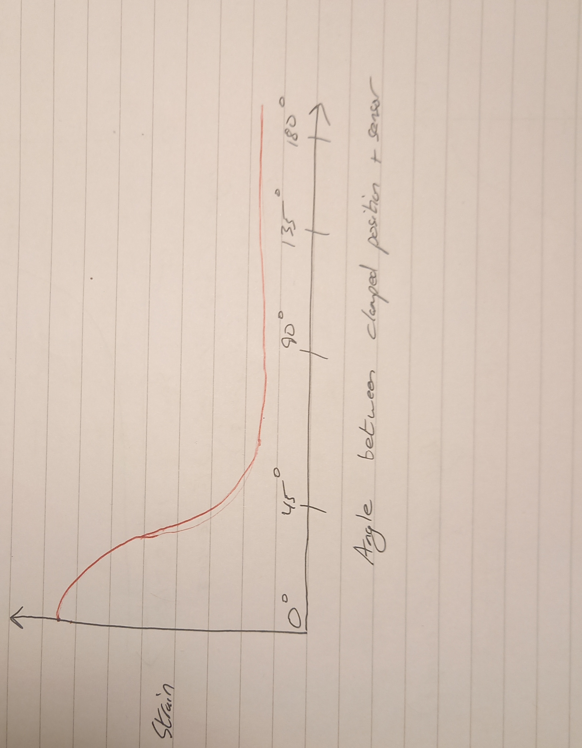*Position 3:* 35 degrees between clamp and sensors

The idea was to get a graph comparing the clamp position’s location around the disc axis to the strain in the sensors at each position, something like the below. The failure to achieve this and the recommendations for future experiments are discussed in the conclusions

Strain

Angle between clamp position and sensor

Figure 1. Rough sketch of expected graph for this investigation

The clamp was to be held in the same position, with the Instron computer giving information on how much the disc rotated around its axis. The Instron was limited to a total of 45 degrees of rotation. The angles of the three positions relative to the workpiece were as follows:

**Experiment’s conditions**

1. Instron
2. Disk 3 mm
3. Three positions of the clamping (Fig. 2)
4. Torque was applied clockwise
5. Sensors: gage factor 2.065; gage resistance 120 Ohm; Vex source – internal; Vex value 2.5 V (Fig. 3).
6. Torque range 10, 20, 30 Nm
7. Port 0 - Strain 0 (information in DAQ system) - Sensor 1

Port 1 - Strain 1 - Sensor 2

Port 2 – Strain 2 - Sensor 3

1. Data file (column 1 - Sensor 1; column 2 - Sensor 2; column 3 - Sensor 3)
2. LabView 2009
3. ¼ quarter bridge I for each sensor

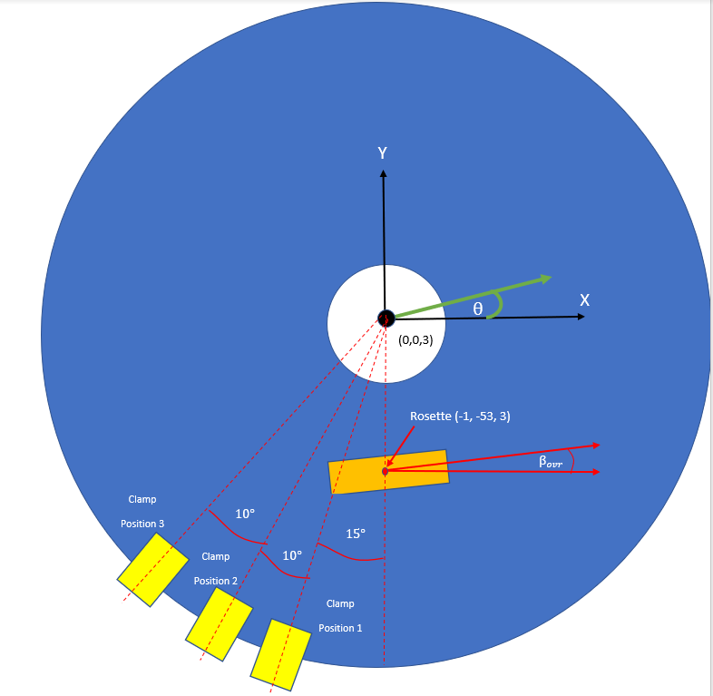

Fig. 2. Diagram of 3 clamped positions on disc

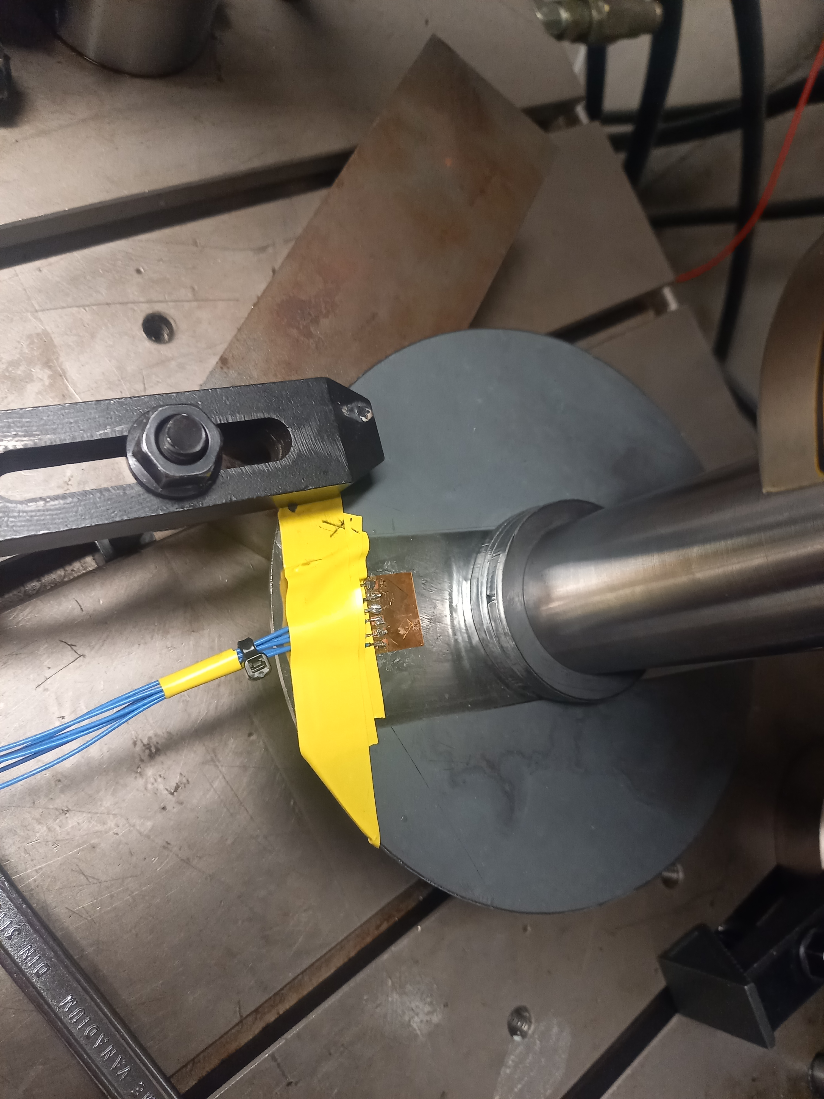

Fig. 3. Experimental set up

**POSITION 1**

Fig. 4. Experimental results for Sensor 1

Note: 30Nm test is unusual- strain in the latter idle stage is lower than that in the initial idle stage

Fig. 5. Experimental results for Sensor 2

Fig. 6. Experimental results for Sensor 3

**Table 1**

|  |  |  |  |
| --- | --- | --- | --- |
|  | **Sensor 1** | | |
| **The torque applied** | **10 Nm** | **20 Nm** | **30 Nm** |
| Idle level | 5.22x10-6 | 6.423x10-6 | 1.16x10-6 |
| Work level | 6.05x10-5 | 0.000110192 | 0.000148 |
| Difference, numerical value | 55.3x10-6 | 10.3x10-6 | 147x10-6 |
|  | **Sensor 2** | | |
| **The torque applied** | **10 Nm** | **20 Nm** | **30 Nm** |
| Idle level | -3.6598x10-6 | -3.096x10-6 | -8.37x10-6 |
| Work level | -5.21x10-6 | -1.25x10-5 | -1.91x10-5 |
| Difference, numerical value | 1.46x10-6 | 9.404x10-6 | 10.73x10-6 |
|  | **Sensor 3** | | |
| **The torque applied** | **10 Nm** | **20 Nm** | **30 Nm** |
| Idle level | 5.724x10-7 | 2.56x10-6 | 4.788x10-6 |
| Work level | 3.47x10-6 | 7.91x10-5 | 1.38x10-5 |
| Difference, numerical value | 2.89x10-6 | 5.35x10-6 | 8.973x10-6 |

**Table 2**

|  |  |  |  |  |
| --- | --- | --- | --- | --- |
| **The torque applied** | 10 | 20 | 20 | 30 |
|  | **Sensor 1** | | | |
| Δ Strain | 4.85x10-5 | | 4.3x10-5 | |
| Δ Torque, Nm | 10 | | 10 | |
| S | 4.85x10-6 | | 4.3x10-6 | |
|  | **Sensor 2** | | | |
| Δ Strain | 0.79x10-5 | | 0.1326x10-5 | |
| Δ Torque, Nm | 10 | | 10 | |
| S | 0.79x10-6 | | 0.1326x10-6 | |
|  | **Sensor 3** | | | |
| Δ Strain | 0.2456x10-5 | | 0.3624x10-5 | |
| Δ Torque, Nm | 10 | | 10 | |
| S | 0.2456x10-6 | | 0.3624x10-6 | |

**The most sensitive sensor in Position 1 – Sensor 1**

**POSITION 2**

Fig. 7. Experimental results for Sensor 1

Fig. 8. Experimental results for Sensor 2

Fig. 9. Experimental results for Sensor 3

30 Nm reading is very unusual- doesn’t return to original strain value when unloaded. This is true for all 3 sensors. The 20 Nm reading is also unusual- its resting state is much more pronounced than those of sensor 1 and sensor 3.

**Table 3**

|  |  |  |  |
| --- | --- | --- | --- |
|  | **Sensor 1** | | |
| **The torque applied** | **10 Nm** | **20 Nm** | **30 Nm** |
| Idle level | -1.03x10-5 | -6.07x10-5 | -1.71x10-5 |
| Work level | 1.88x10-6 | -3.84x10-5 | -5.16x10-5 |
| Difference, numerical value | 1.22x10-5 | 2.23x10-5 | 3.45x10-5 |
|  | **Sensor 2** | | |
| **The torque applied** | **10 Nm** | **20 Nm** | **30 Nm** |
| Idle level | -1.16x10-5 | -2.71x10-5 | -1.42x10-5 |
| Work level | -2.04x10-5 | -4.71x10-5 | -5.57x10-5 |
| Difference, numerical value | 0.88x10-5 | 2x10-5 | 4.15x10-5 |
|  | **Sensor 3** | | |
| **The torque applied** | **10 Nm** | **20 Nm** | **30 Nm** |
| Idle level | -1.15x10-5 | -1.93x10-5 | -1.31x10-5 |
| Work level | -1.83x10-8 | 1.94x10-6 | 1.58x10-5 |
| Difference, numerical value | 1.15x10-5 | 2.12x10-5 | 2.89x10-5 |

**Table 4**

|  |  |  |  |  |
| --- | --- | --- | --- | --- |
| **The torque applied** | 10 | 20 | 20 | 30 |
|  | **Sensor 1** | | | |
| Δ Strain | 1.01x10-5 | | 1.22x10-5 | |
| Δ Torque, Nm | 10 | | 10 | |
| S | 1.01x10-6 | | 1.22x10-6 | |
|  | **Sensor 2** | | | |
| Δ Strain | 1.12x10-5 | | 2.15x10-5 | |
| Δ Torque, Nm | 10 | | 10 | |
| S | 1.12x10-6 | | 2.15x10-6 | |
|  | **Sensor 3** | | | |
| Δ Strain | 0.97x10-5 | | 0.77x10-5 | |
| Δ Torque, Nm | 10 | | 10 | |
| S | 0.97x10-6 | | 0.77x10-6 | |

**The most sensitive sensor in Position 2 – Sensor 2**

**POSITION 3**

Fig. 10. Experimental results for Sensor 1

Fig. 10. Experimental results for Sensor 2

Fig. 11. Experimental results for Sensor 3

**Table 5**

|  |  |  |  |
| --- | --- | --- | --- |
|  | **Sensor 1** | | |
| **The torque applied** | **10 Nm** | **20 Nm** | **30 Nm** |
| Idle level | -9.91x10-6 | -1.26x10-5 | -1.27x10-5 |
| Work level | -3.49x10-5 | -6.61x10-5 | -9.72x10-5 |
| Difference, numerical value | 2.5x10-5 | 5.35x10-5 | 8.45x10-5 |
|  | **Sensor 2** | | |
| **The torque applied** | **10 Nm** | **20 Nm** | **30 Nm** |
| Idle level | -1.25x10-5 | -1.81x10-5 | -2.08x10-5 |
| Work level | -2.19x10-5 | -3.90x10-5 | -5.12x10-5 |
| Difference, numerical value | 0.94x10-5 | 2.1x10-5 | 3.04x10-5 |
|  | **Sensor 3** | | |
| **The torque applied** | **10 Nm** | **20 Nm** | **30 Nm** |
| Idle level | -1.13x10-5 | -1.52x10-5 | -1.64x10-5 |
| Work level | -1.83x10-6 | 1.25x10-5 | 2.61x10-5 |
| Difference, numerical value | 1.31x10-5 | 2.77x10-5 | 4.25x10-5 |

**Table 6**

|  |  |  |  |  |
| --- | --- | --- | --- | --- |
| **The torque applied** | 10 | 20 | 20 | 30 |
|  | **Sensor 1** | | | |
| Δ Strain | 2.85x10-5 | | 3.1x10-5 | |
| Δ Torque, Nm | 10 | | 10 | |
| S | 2.85x10-6 | | 3.1x10-6 | |
|  | **Sensor 2** | | | |
| Δ Strain | 1.16x10-5 | | 0.94x10-5 | |
| Δ Torque, Nm | 10 | | 10 | |
| S | 1.16x10-6 | | 0.94x10-6 | |
|  | **Sensor 3** | | | |
| Δ Strain | 1.46x10-5 | | 1.48x10-5 | |
| Δ Torque, Nm | 10 | | 10 | |
| S | 1.46x10-6 | | 1.48x10-6 | |

**The most sensitive sensor in Position 3 – Sensor 1**

**Conclusions.**

**1.** The compressive strain present in sensor 2 for position 2 increases after unloading. This is unusual- perhaps an unexpected strain pattern is occurring.

**2.** The strain doesn’t return to the original idle state values after unloading in the below two scenarios.

Position 2 sensors 1 and 2 (for 30 Nm only)

Position 3 sensors 1 and 2 (for all torques)

Either hysteresis is present, or the return to the idle state values take place over a longer period than the recorded period

3. For position 3, the 30 Nm test values are unusual again- sensor 1 and sensor 3 experience a spike in strain after unloading which quickly returns to resting state.

3. The most sensitive sensor in Position 1 – sensor 1;

The most sensitive sensor in Position 2 – sensor 2

The most sensitive sensor in Position 3 – sensor 1.

Different sensors were more sensitive in different positions. Sensor 1 is oriented closest to the 55 degree angle which was taken from ANSYS results to be the optimal orientation to catch strain at a variety of clamped positions.

**Comparing strain in sensors for different positions on same graph**

**Sensor 1:**

* High tensile strain when clamp at position 1.
* Slightly lower tensile strain when clamp at position 2
* Compressive strain when clamp at position 3

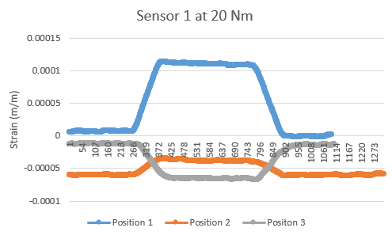Fig. 12. Experimental results for Sensor 1 at 20 Nm

**Sensor 2:**

* Low compressive strain when at position 1
* Higher compressive strain when at positions 2 and 3 (similar values)
* Unusual increase in strain in unloaded state in position 3

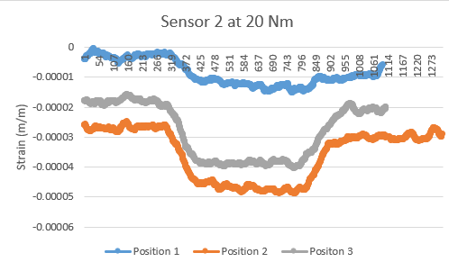

Fig. 13. Experimental results for Sensor 3

**Sensor** **3**

* Low tensile strain for position 1
* High compressive strain when in unloaded states for positions 2 and 3. However, this gets much more positive as load is applied.
* Unusual decrease in strain in final unloaded stage at 30Nm for position 2
* Unusual spike in strain in final unloaded stage at 30 Nm for position 3

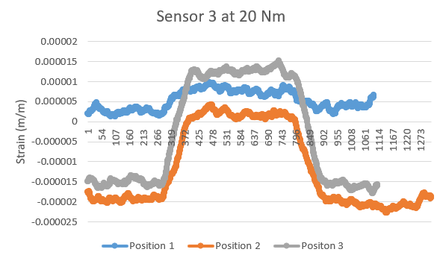

Fig. 14. Experimental results for Sensor 3

**Conclusions**

1. As the clamp position changes, the strain type can also change- sensor 1 experiences tensile strain in position 1, but compressive strain in positions 2 and 3. An analysis of this should be completed, in line with conclusion 4 below.
2. The disc was not clamped exactly at the 15 degrees, 25 degrees and 35 degrees to the sensor as was intended. This was because it was difficult to obtain a consistent contact area between the clamp and the disc. Future experiments should rectify fault to obtain the graph shown in Figure 1.

A recommendation for how to fix this is to fix an intermediate body between the disc and the clamp. If the body can be attached to the disc before placing it in the Instron, the clamping force would go through the intermediate body and into the disc. Thus, the intermediate body would be clamping the disc in a manner that is accurate, repeatable and easier to simulate.

An example for this would be to put a washer at either side of the disc where it meets the clamp. The washer area can be modelled as the “fixed geometry” in ANSYS, and the washer position can be measured much easier than the clamp position.

1. The Instron total rotation limit of 45 degrees limits the range of values this experiment can be carried out for. Ideally, the strain would be captured as the angle between clamped position and sensor goes all the way to 180 degrees (possibly 360 for directional analysis).

It can be achieved by moving the clamps and keeping the disc still. This experiment did it the other way around- it was thought that the rotation angles given on the Instron would aid accuracy, but difficulties in accurately clamping the disc in the right place made it inaccurate. The clamp accuracy difficulties can be resolved with the suggestions from Conclusion 1 above.

1. The principal strain can be obtained by subbing strain values from the rosette strain gauge’s 3 sensors into the formula below. Here $∈_{p,q}$ is the value of the primary strain, with θ being its angle with respect to the X axis (Figure 2). This will be useful for getting information about the strain patterns in the disc. This should be investigated in the coming few weeks.

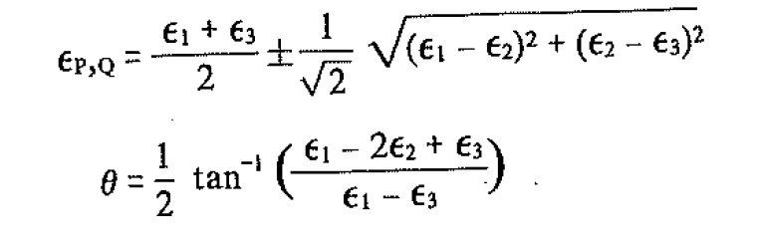

**Figure 15-** Formulae for principal strain